# PROJECT PROPOSAL: Beyhive Vs rocnation

## Team Members

TTH

Jason Carey

Jordan Gross

Kabrina Ramnath

Omar Trejo

## Project Description:

Our project is to create an interactive Leaflet and D3 visualization displaying concert attendance records, streaming views, album sales, and unique lyric text analysis for Beyonce and Jay-Z. We will use a combination of web scraping and API’s to obtain the data from our sources.

## Datasets:

Wikipedia – Concert attendance

Genius - lyrics

Spotify, Itunes, Youtube, Billboard– streaming and album sales data

## Github link:

https://github.com/otrejo08/data_bootcamp_project2

## Screenshots:

One HTML page with a 4 panel display

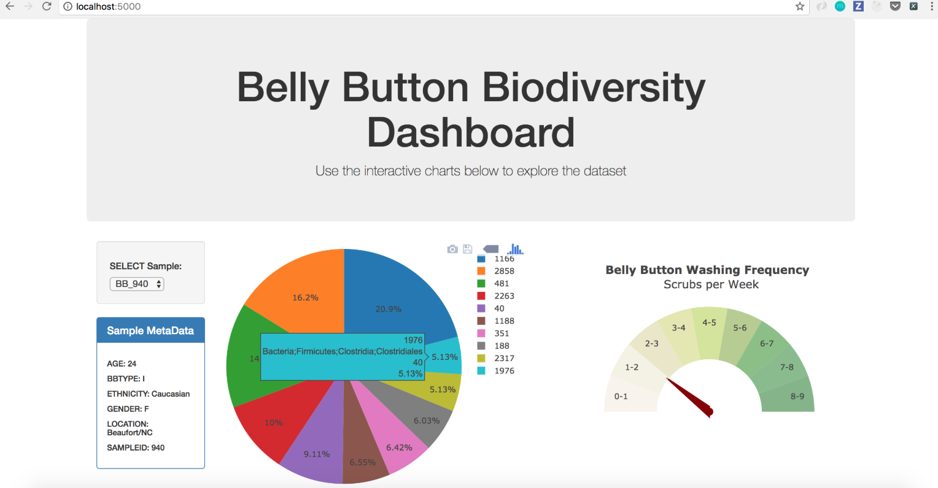

Lyrical text analysis

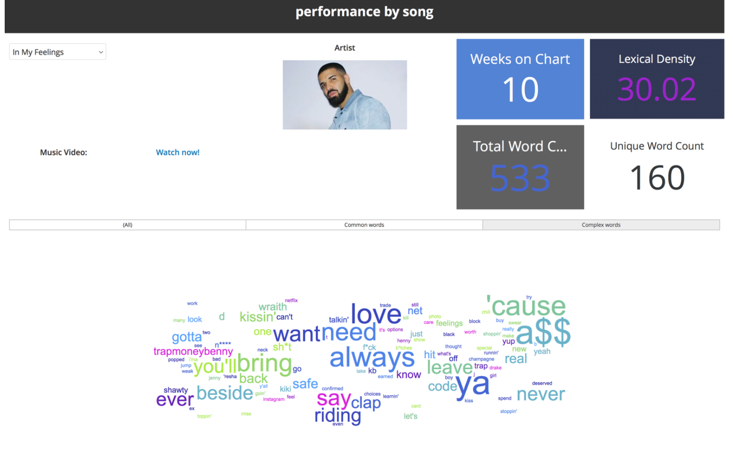

Album sales and streaming charts

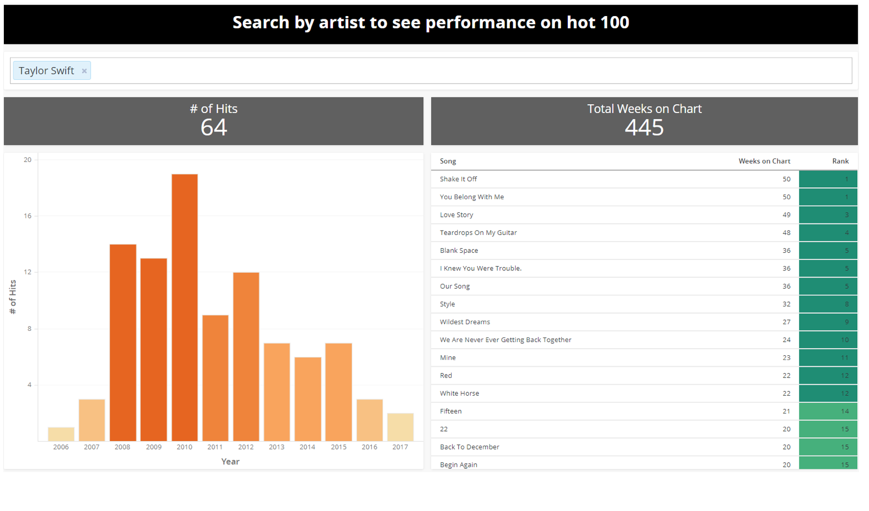

Leaflet map

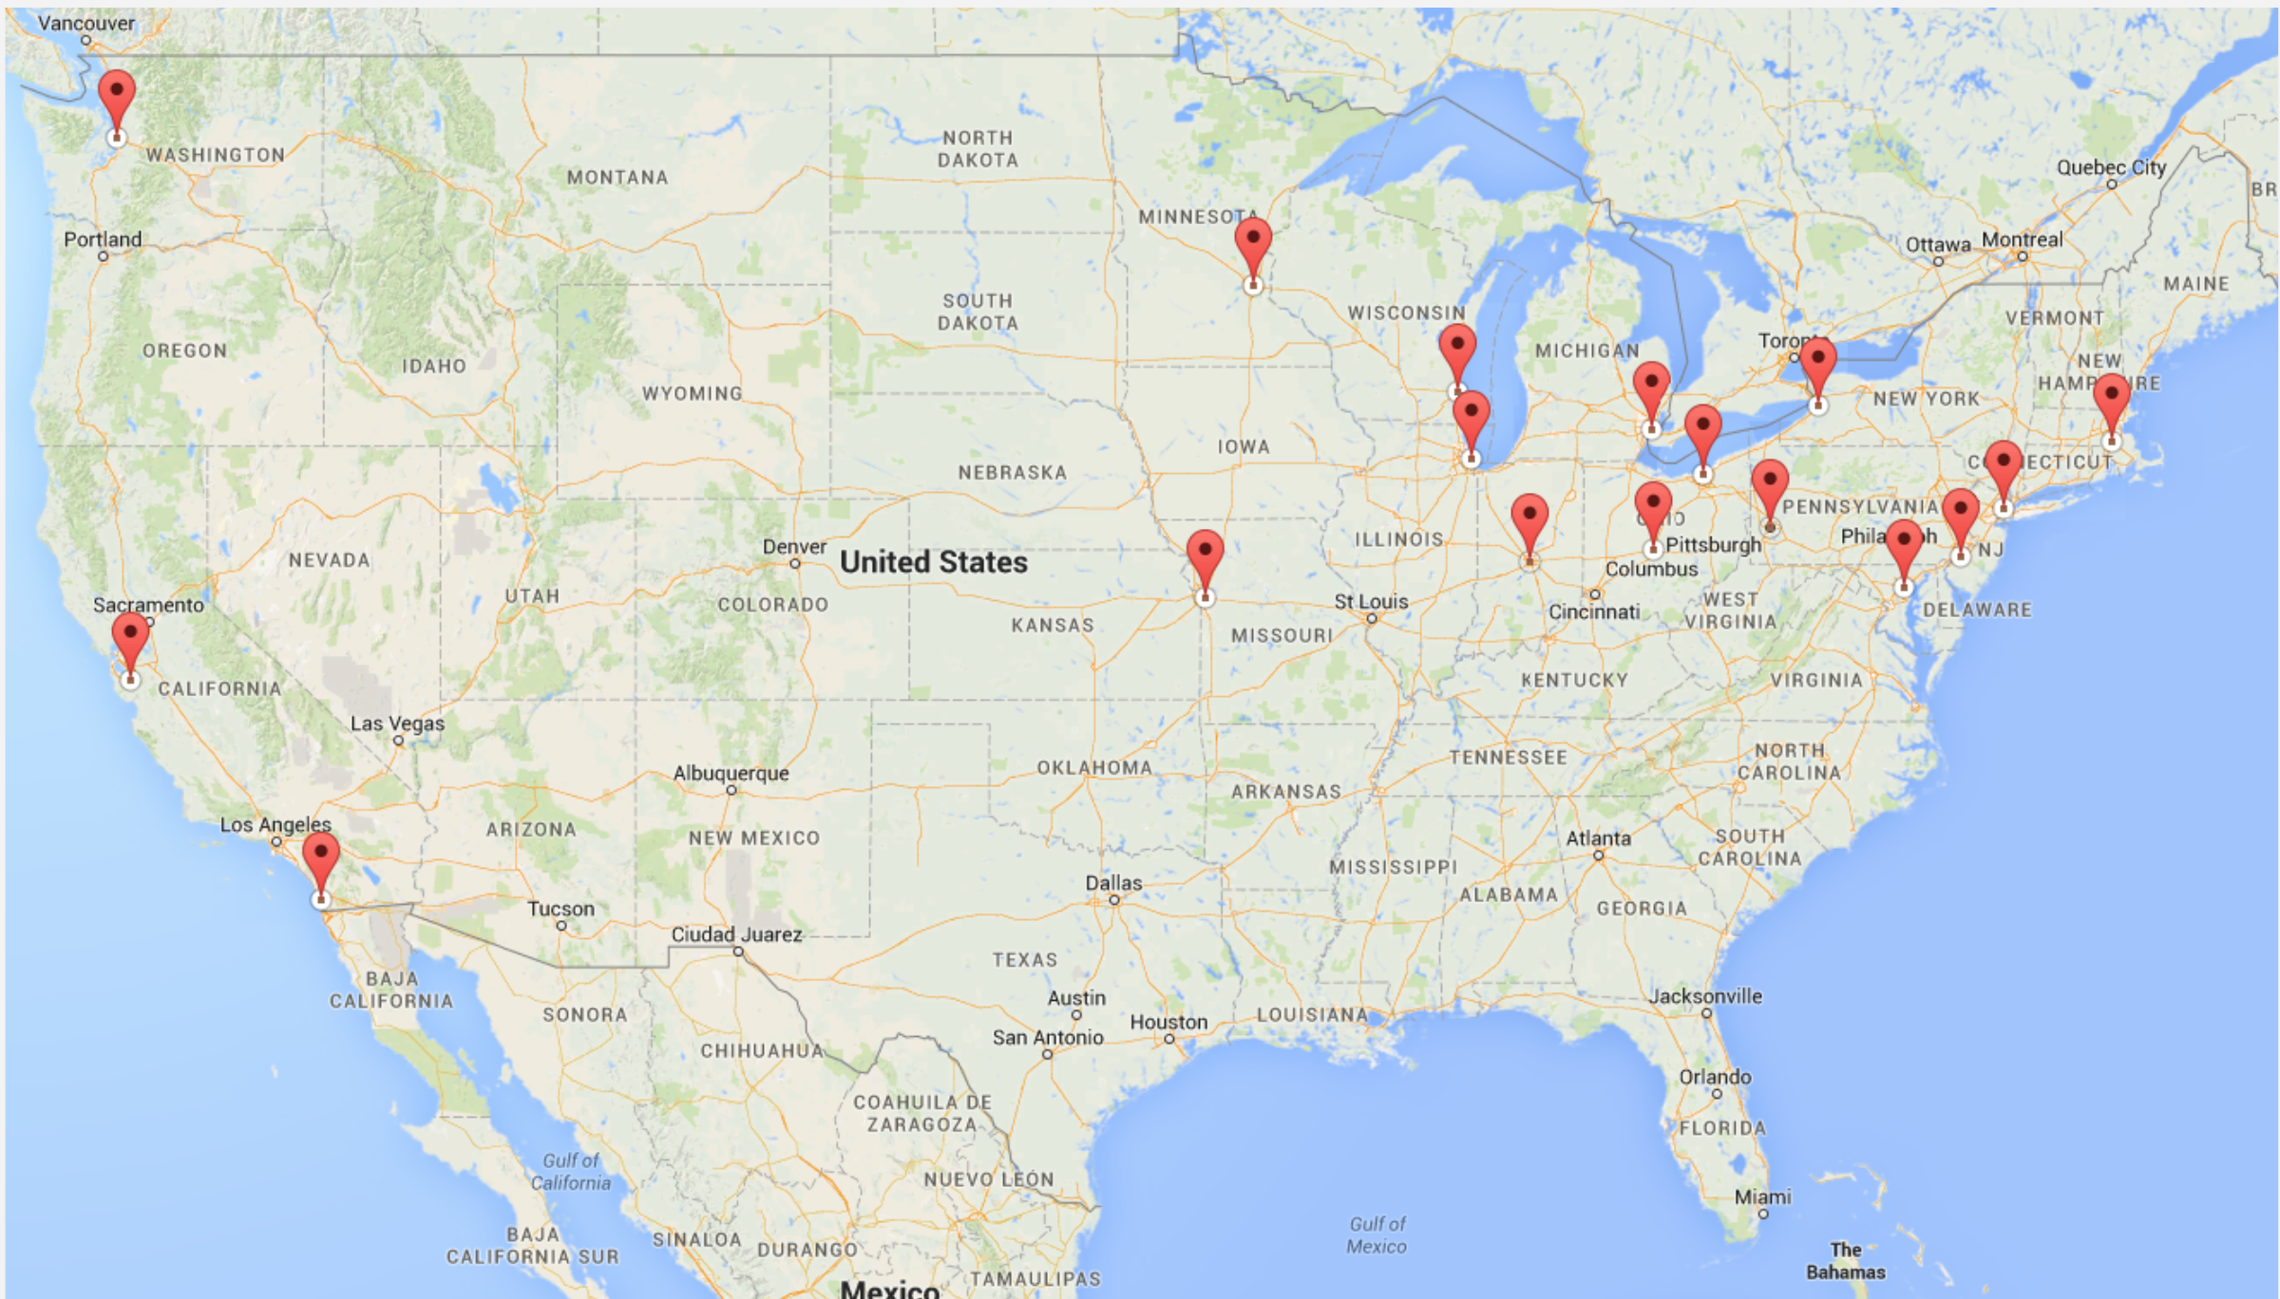

Sketch

